Terahertz Spectroscopy Measurements on Black Silicon
by
Jesper Graungaard Bertelsen
AU-ID: au689481, Study-ID: 202204617

Bachelor’s Thesis
in
Electrical Engineering

Supervisor:
Pernille Klarskov

Co-Supervisor:
Rasmus Davidsen

Aarhus University, Department of Electrical and Computer Engineering
<date of submission, e.g. 5 December 2025>

Indholdsfortegnelse
Abstract 3
Introduction 3
Eksperimental setup 3
Verifying the setup 4
Methods and theory 5
Black sillicium 5
Terahertz Time-domain Spectroscopy ( THz-TDS ) 5
Usikkerhedsberegninger 6
Experimental results 7
Discussion 8
Future work 8
Conclusions 8
References 8
Bibliografi 8

Opstilling taget fra eksempel:
- Abstract
- Introduction
- Literature Review
- Methodology
- Analysis and Discussion
- Future Work
- Conclusions
- References

Abstract

Introduction

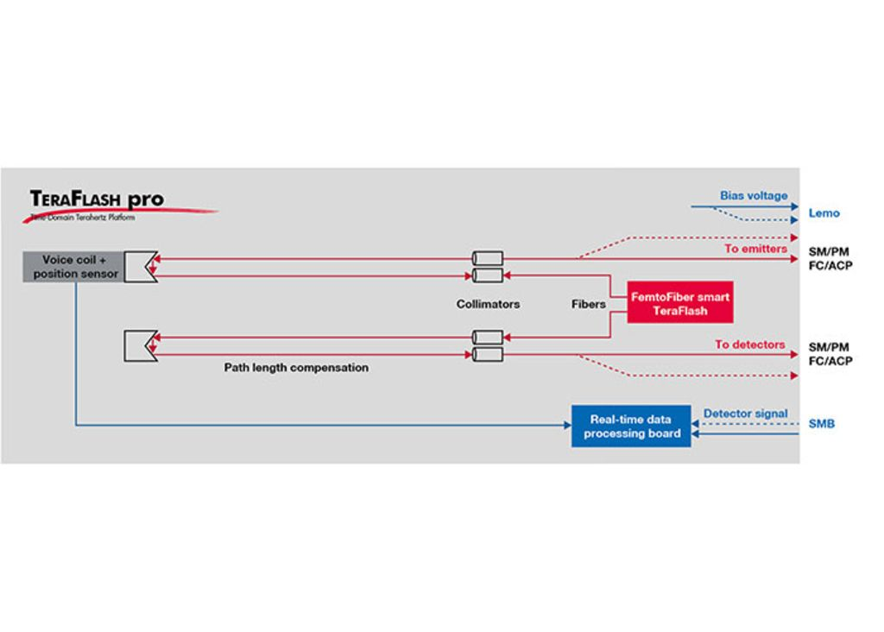
Eksperimental setup
Grej til rådighed, TeraFlash Proen af toptica.
Bord hvor man kan skrue ting fast på. Apperaturer til at holde spejle på plads og ellers justere højden for mediummet.
Grejet fra toptica bruger en FemtoFiber Smart TeraFlash laser,
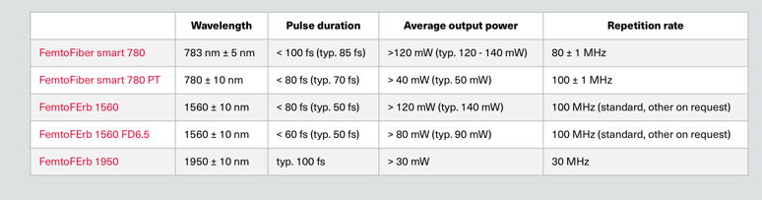
https://www.toptica.com/products/ps-fs-fiber-lasers/femtofiber-smart
På deres hjemmeside har de to kandidater som hedder noget lignende. Time steppet efter sampling afslører, at det er en 0,05ps = 50fs pulse. Dermed er det enten
FemtoFErb 1560 eller FemtoFErb 1560 FD6,5.

Verifying the setup
When having set it all up, we then want to verify, that all is working accordingly. This ensures, that the values I’ll later get can be interpreted correct. For what I’ll be using THz TDS for, it’s to describe etching of the black sillicon reference material. The refractive index of Si is well known and with the depth being known aswell, we should see the refractive index convergerging towards the refractive constant.
Using a change in refractive index of two mediums and taking that in terms of how it affects the change in phase, one can derive an expression for a uniform material to be:
$$n_{si}=\left|∆ϕ\right|·\frac{c}{ω·d}+n_{0} ⋆1$$
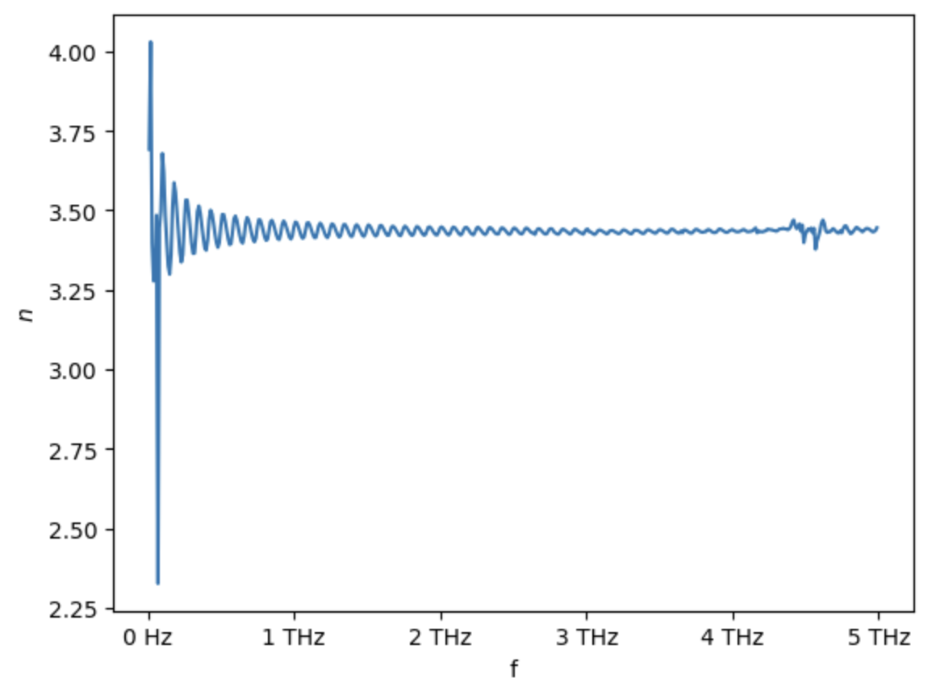
Which we can use for analysis in the frequency domain. [1]
Figure 1: The refractive index of Si varying over frequencies

Due to singularities for $\lim_{ω→0}{n_{si}\left(ω\right)}$ there is methods for overcoming that, making a new refractive index using what’s known as Phase Extrapolation
$$n_{si}^{'}\left(ω\right)=n_{si}\left(ω\right)+m·2π\frac{c}{ωd} ⋆2$$
For m being an arbitrary integer, that ensures, that the best results is seen around $ω=0$. [2]
For my reference sample, $m=0$ made for the best result, meaning that phase extrapolation didn’t help.
Then drawing conclusions from the figure, I saw my refractive index converging towards an approximate of $n_{si}≈3,43$, which are a value of the refractive index one could expect. Having gotten that verification made me able to move on towards new steps.

Methods and theory

Black sillicium
Med dens lave reflektivitet, så er black sillicium et godt materiale når det kommer til at inkapsle solens stråler, som er essencen i en solcelle…
Jeg ved ikke meget om det, men vil give det lidt tid, og prøve at få lidt teori om det indover også.

Terahertz Time-domain Spectroscopy ( THz-TDS )
Terahertz Time-domain Spectroscopy is an optical measurement tool, used within a wide range of academic fields. From the application in medical field, where it has been shown to detect skin cancer, to the field of security and more [3]. Within the field of material science, it’s also being used as an alternative method to conventional methods of using electronics.
Terahertz? Hvorfor? Hvad er motivationen bag?
Transparency range SI ( 1,2um til 9um)
$v=λ·f, f=\frac{c}{λ}$
$c≔3·{10}^{8}\frac{m}{s}$
$$f=\left\{\begin{aligned}\frac{c}{9·{10}^{-6}m} \\ \frac{c}{1,2·{10}^{-6}m}\end{aligned}\right\}=\left\{\begin{aligned}33,3\overline{3} \\ 250\end{aligned}\right\}\left[THz\right]$$
Så terahertz er blandt andet nyttig til at infiltrere i Si.

Terahertz TDS? Motivationen bag?
Terahertz TDS? Hvordan?

Tutorial: An introduction to terahertz time domain spectroscopy (THz-TDS), alt hvad der står I den:
“Terahertz time-domain spectroscopy (THz-TDS… It has been used for contact-free conductivity measurements of metals, semiconductors, 2D materials, and superconductors. Furthermore, THz-TDS has been used to identify chemical components such as amino acids, peptides, pharmaceuticals, and explosives, which makes it particularly valuable for fundamental science, security, and medical applications”
- INTRODUCTION

“There are also applications where THz-TDS is being optimized for the detection of bombs, drugs, and weapons”
“In the field of materials science, THz-TDS is ideally suited to measure mobile charge carriers since they reflect and absorb THz radiation”
“The interest in THz-TDS from the medical community has been growing in recent years. Proof-of-concept experiments are able to detect skin cancer”

Terahertz? Hvad er motivationen bag.
Terahertz vides at have nogle egenskaber i de forskellige akademiske felter. Hvad vil det kræve? Traditionel består? Optik kun?

Terahertz TDS? Motivationen bag:
Traditionelle elektroniske metoder er begrænset af sampling speeden. ADC bruger zero-order hold eller andre metoder, men som med elektronik, så er de metoder begrænset af rise og fall time. Hvis følgende ikke gælder, at $s\left(t\right)≫r\left(t\right)∩f\left(t\right)$ så betyder de samplede informationer ikke meget. I metoder hvor man har brug for meget stor tids resolution, så er der derfor ikke hjælp at hente på den traditionelle måde gennem elektronikken.
Da må man finde andre metoder. Optik har ikke samme begrænsninger som elektronikken, så en metode ved brug af det kunne give muligheder…
Det elektriske felt ved detektor varer typisk kun få picosekunder. Den traditionelle elektronik har rise og fall time i netop picosekunder. Det giver derfor ikke mening, at bruge de metoder til at sample nyttig information. [4]
Optik trin. Hvordan samples der?
Ved brug af convolution. Signalet kan beskrives propoere med $S\left(t\right)∝I_{opt}\left(t\right)E_{THz}\left(t\right)$ som er den øjeblikkelige værdi. Hvis man forskyder tiden, så kan beskrive det ved konvolution:
$S\left(t_{1}\right)∝I_{opt}\left(t\right)⋆E_{THz}\left(t_{1}\right)$
Med optikkens intensitet kommende fra en puls, som er noget kortere end terahertz feltets signal, så kan den næsten ses som en impuls. Konvolution med en impuls er signalet tidsforskudt til impulsens tid.
Hvorfor vi implementerer delay lines.

Hvordan laves det elektriske THz felt? ( PCA )
$E_{THz}\left(t\right)∝w_{0}·\frac{\sin\left(α\right)}{r}·\frac{d}{dt_{r}}\left(\left|I_{PC}\left(t_{r}\right)\right|\right)$ $\left(6\right)$
r er afstanden og og $α$ er vinklen, som man observerer terahertz feltet fra. $t_{r}$ er den retarderede tid, $I_{PC}\left(t_{r}\right)$ er strømmen i photoconducteren. [5]
Jo egentlig simpel. Du biaser dit kredsløb med en bias voltage, som passer med, at din laser kilde vil få strøm til at løbe igennem de to plader som virker som kondensatorer.
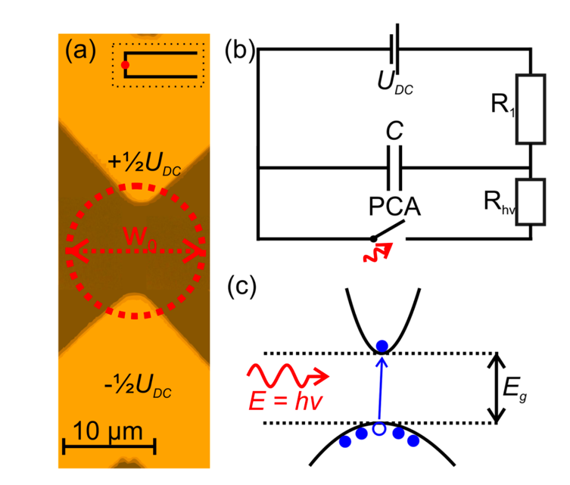

Hvordan opfanges det elektriske THz felt? ( PCA )
“THz detection via photoconductive switches can be performed with similar or even identical devices as used for THz generation. In contrast to generation, the metal gap fabricated on the semiconductor is not externally biased” [6] <- Giver mening. Uden tab burde det exciterede photon.fra generatoren være lig med bandgappet ved receiveren.

Carrier lifetime ved receiveren er i ordnen 100-300 fs og laver strømme af ordnen nA.
Det er nogle stærke krav til systemet, hvor at termisk støj kan beskrives som
$U_{noise}=\sqrt{\frac{k_{B}T}{C}}$
Hvor kapacitansen kan beskrives som $C≈10fF$. Da vil der gælde ved en stuetemperatur på 295 Kelvin. :

$$Definer: k=1,3806504·{10}^{-23}J·K^{-1}$$
$$U_{noise}=\sqrt{k·\frac{295K}{10·{10}^{-15}F}}≈650μV$$
Resistancen af antennaen kan siges at have en størrelse på 1MΩ. Da vil strømmen påført af strøm være i ordnen.
$$I=\frac{650·{10}^{-6}V}{1·{10}^{6}Ω}=650nA$$
Da vil støjen være på samme niveau som signalet, og derfor er det triggy at skelne mellem de to. [6]

Filter.

Flow chartet.

- CONCEPT OF TIME-DOMAIN SPECTROSCOPY (TDS)
“The THz electric field at the detector is typically on the order of 10–100 V/cm65 and has a time duration of a few picoseconds” <- Krav
Direct electrical detectors and circuits usually have rise times and fall times in the picosecond to nanosecond range and, therefore, do not have high enough time resolution. <- Konventionelle metoder
The way to reach sub-picosecond resolution is by using optical techniques wherein an ultrashort NIR optical pulse (typically shorter than 100 fs) is beamsplit along two paths to generate and detect the timedependent THz field. Measuring in the time-domain is based on sampling the
unknown THz eld with a known femtosecond laser pulse, which is referred to as the read-out pulse. THz-TDS uses the
convolution of a short read-out pulse with the longer THz pulse <- Hvordan så?

$S\left(t\right)∝I_{opt}\left(t\right)E_{THz}\left(t\right)$ $\left(1\right)$
”All existing detectors are too slow, so the convolution $⋆$ of the two pulses is measured instead”
$S\left(t_{1}\right)∝I_{opt}\left(t\right)⋆E_{THZ}\left(t_{1}\right)$ $\left(2\right)$
“Since the optical pulse is significantly shorter than the THz pulse, it can be approximated as a delta-function”
$S\left(t_{1}\right)∝I_{opt}\left(t\right)⋆E_{THZ}\left(t_{1}\right)≈δ\left(t\right)⋆E_{THz}\left(t_{1}\right)=E_{THz}\left(t_{1}\right)$
Så hvad? Fordi at den konventionelle metode for at beregne signalet i
det digitale ikke har tilstrækkeligt tidsresolution, så kan vi ikke måle det.
Derfor tyder vi til det optiske, hvor vi kan bruge egenskaberne af konvolution. Bemærk, at her ser vi på det elektriske felt til en valgt tid. Noget som ser uendeligt småt ud i konvolution kan ses som et impuls. Konvolution med et impuls giver den samme, bare tidsforskudt til impulsens tid. Med reference i impulsen, så vil den ikke blive forflyttet.
”…we measure the timedependent amplitude E(t), in contrast to other techniques such as FTIR which measure only the intensity [E2(t)] of an electromagnetic signal and, therefore, do not capture the phase information” <- Hvorfor THz-TDS er interesant.
“The measured signal corresponds to the THz eld amplitude at a single point in time (t1). The next step is to measure the signal at all time-points”

Hvad jeg snakkede om med feltet til en enkelt tid.
“The travel time of a laser pulse is t = s/c, where s is the path length and c is the speed of light (this corresponds to 30 cm/ns or 300 μm/ps)”
“Precise micro positioning is achieved with computer-controlled positioning stages”
“The round trip delay time changes 6.6 fs for each micrometer of delay line displacement”

$t=\frac{d}{v}$
$v=\frac{d}{t}≈\frac{300μm}{ps}$
$t\left(d\right)≔\frac{d}{\frac{300μm}{ps}}$
$t\left(1μm\right)=3,33333·{10}^{-15} s$
Jeg får godt nok 3,3fs som mit resultat. Men det er vidst ligegyldigt.
“Water vapor has strong absorption features in the THz range that can interfere with measurements.66,67 To minimize this absorption, the THz beam path is enclosed in a purge box (see Fig. 1)” <- Taler til usikkerheden ved metoden.

Kommet hertil.

Sampling I THz TDS
Forstyrrelse af medium.
Hvorfor vi bruger [0,8; 1,15] THz på grund af at $λ_{0}≫d_{film}$, som gør det muligt at approksimere til en tyndfilmsformel. $(d_{film}≪λ_{\text{eff}})$, (
Yasiths side 12.
40. Beermann, N. S.; Gebauer, A.; Fabretti, S.; Zhang, W.; Hiraoka, T.; Achtstein, A. W.; Hafez, H. A.; Turchinovich, D. Terahertz time-domain spectroscopy for simultaneous measurement of optical constants, and material thickness with deep-subwavelength precision. Optics Express 2025, 33 (6), 8650–8660. DOI: 10.1364/OE.544182
)
0,8THz er valgt af Yasith pga, stabilitet. $λ_{min}=260,9μm=>f_{max}=1,15THz$ og $d_{film}≪λ_{min}$, så jeg kunne egentlig have valgt en vilkårlig bølgelængde højere end det. Men som sagt, 0,8THz er taget pga. stabilitet.

Usikkerhedsberegninger
Da det kan være meget svært at udlede et udtryk, hvor man simpelt kan sige, at går dette udtryk mod A, så vil mit udtryk gå mod min/max, så gik jeg videre til at bruteforce beregninger.
Operationerne
Til operationerne varierer jeg først på (dref, dsam, dfilm) til indekserne (j, k, i). Dernæst varierer jeg for alle de scans som jeg gjorde til hvert type, M = 5, med indeks m.
$avg\left\{n_{f, j, k, i}\right\}$ <- Spektret fra [0,8THz; 1,15THz]. Avg. medføre en skalar
$n_{f max}=\max_{m}{\max_{j}{\max_{k}{\max_{i}{avg\left\{n_{f, j, k, i, m}\right\}}}}}$ <- Upper bound.
$n_{f mean}=\underset{m}{avg}{\underset{j}{avg}{\underset{k}{avg}{\underset{i}{avg}{avg\left\{n_{f, j, k, i, m}\right\}}}}}$ <- Mean value.
$n_{f min}=\min_{m}{\min_{j}{\min_{k}{\min_{i}{avg\left\{n_{f, j, k, i, m}\right\}}}}}$ <- Lower bound.
Og det samme for volume fraction
${volFrac}_{ max}=\max_{m}{\max_{j}{\max_{k}{\max_{i}{avg\left\{{volFrac}_{j, k, i, m}\right\}}}}}$ <- Upper bound.
${volFrac}_{mean}=\underset{m}{avg}{\underset{j}{avg}{\underset{k}{avg}{\underset{i}{avg}{avg\left\{{volFrac}_{j, k, i, m}\right\}}}}}$ <- Mean value.
${volFrac}_{min}=\min_{m}{\min_{j}{\min_{k}{\min_{i}{avg\left\{{volFrac}_{j, k, i, m}\right\}}}}}$ <- Lower bound

Experimental results
Instead of the uniformly distributed Si wafers, these types were now the result of etching the reference substances, for them to have a layer of both air and Si.

I then need an expression, that tries to find the effective refractive index given the depth of the reference, the sample and the depth of the thin film layer.
Lines formel 5.6…

Efterfinde Yasiths resultater for typerne. Kan jeg få alle de samme resultater?
Da det var så svært at efterfinde de resultater som Yasith fik, hvor meget har usikkerhederne så påvirket det?
Usikkerheder antaget anden viden ikke haves: $d_{film}±0,5μm$, $d_{ref}, d_{sam}±20μm$ ( som anvist på deres pakker, tror jeg, at det var ).
Metode
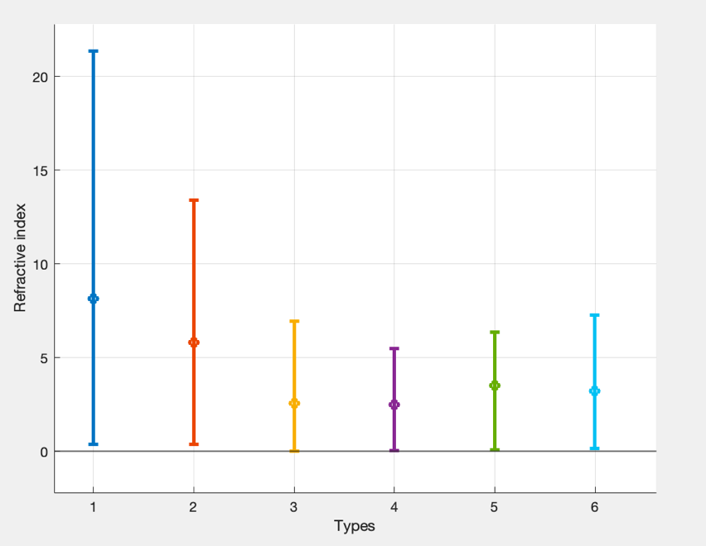
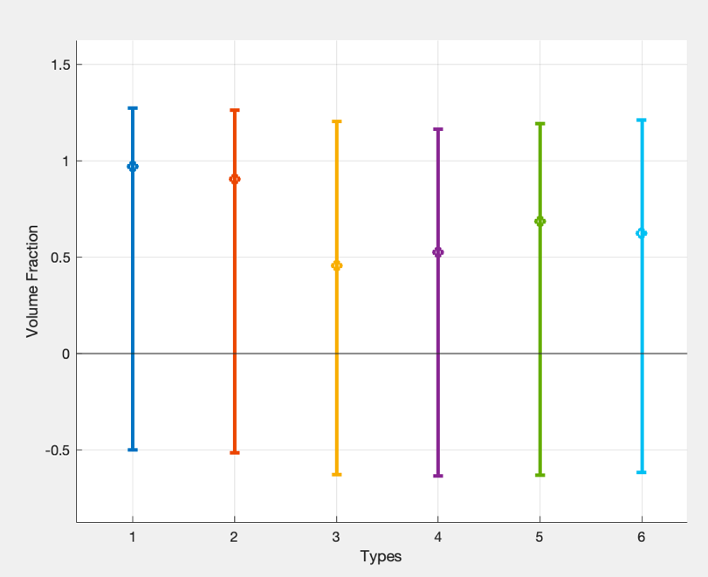
Type plot for refractive indices and volume fraction, due to uncertainties of $d_{film}±0,5μm$, $d_{ref}, d_{sam}±20μm$

Discussion

Future work

Conclusions

References
https://www.toptica.com/products/terahertz-systems/time-domain/teraflash-pro?gad_source=1&gad_campaignid=11174164687&gbraid=0AAAAACcXkr4qej04YU3L2IcDEkUEAKXEg&gclid=Cj0KCQiAxJXJBhD_ARIsAH_JGjhTIgyeGvxpCblPZhtStP0b_JkqpdiC-K26FiAEXBBShBT-Nh_CbYQaAqNuEALw_wcB#gallery-1
https://www.youtube.com/watch?v=X7vrvQcmy8c

Bibliografi

[1] | L. Madsen, »3.2 Refractive index by phase shift,« Terahertz Time Domain Spectroscopy for characterizing thin films, 3 June 2001.

